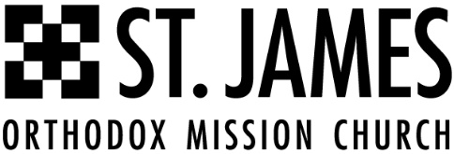

Dear Potential Sponsor,

St James Orthodox Mission Church in Dallas is planning our 2nd annual benefit golf tournament to raise funds for both the International Rescue Committee (https://help.rescue.org/) and the Church Building Fund. The golf tournament will be held on May 6, 2023, at the Bear Creek Golf Club in Dallas, TX.

Since its inception, the focus of our church and its members has been to serve our community through charitable acts both locally and abroad. Our parish devotes funds and time to various charitable organizations, including Baal Dan, Ronald McDonald House, and Mosaic Family Services.

This year, we are partnering with International Rescue Committee and will be donating a portion of the funds raised through the tournament to assist that organization with providing refugee services to displaced Ukrainian families, as well as support those displaced due to the recent devastation in Turkey and Syria.

Our church is incorporated as a 501(c)(3), and all contributions to this charity golf fundraiser are fully tax-deductible. We are looking for individuals, organizations, and businesses to sponsor each of the 18 holes of the golf course. By being a sponsor, you will be promoting your company or organization to a diverse group of tournament participants while simultaneously supporting a great cause. The robust list of sponsor benefits is attached. Even if you’re unable to commit to sponsoring a hole, we are in need of donations for prizes, giveaways, and more. Any donation of funds or items is welcome and appreciated.

For further information, please contact the following members of the St. James Orthodox Mission Church Fundraising Committee:

- Tournament Chair: Steven Philips, 972-998-1296
- Co-Tournament Chair: Joe Kunnathusseril, 972-567-2613
- Events Coordinator / Lead Advisor: Vinson George, 214-418-4381
We are anticipating a highly successful and well-rounded Golf Tournament. We humbly request your commitment and support for this event.

Sincerely,

St James Tournament Committee

SPONSOR 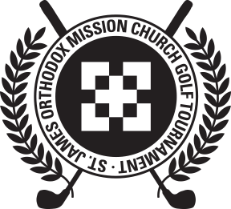 DETAILS__
Also Available Online at: https://www.stjamesmissionchurch.org/2023-golf-tournament
Organization: _________________________________________
Contact: _____________________________________________
Phone No. (required):_______________________________
Email (required): _____________________________________
Address: ____________________________________________
City: _______________________ State: ______ Zip: ________
Sponsorship Level: ______ Hole # ______ Title or Preferred Y/N ____

TOURNAMENT HOLE SPONSOR: 14 spots @ $1,000 each
- Registration: covered for a team of four players, with the full $600 registration fee waived.
- Advertising: Company logo advertised on the golf tournament website and social media pages
- Hole: Name is listed on a group sign that is displayed at the tee on one of the golf course holes
- Cart: Name is displayed on the front or rear of a golf cart
- Banner: Provided sign, billboard, or banner to be displayed at a prominent location on the golf course
- Other Signage: Exclusive advertising on one of the greens or putting areas to display product or service and a banner
- Club House: Logo displayed on program
- Podium: Opportunity to speak about their company or cause to individuals participating in the tournament during dinner and prize distributions
TOURNAMENT PREFERRED HOLE SPONSOR: 2 spots @ $1,250 each [pending availability]
Same Benefits as Tournament Hole Sponsor, but for Holes 9 and 10, in close proximity to Clubhouse, plus:
- Merchandise/Marketing Material in Golfer Gift Bags: St. James tournament committee will work to support/supply merchandise to include in Golfer Gift Bags if you don’t have readily available stock of marketing merchandise (a budget for this has been pre-determined by the tournament committee

TOURNAMENT TITLE SPONSOR: 2 spots @ $1,500 each [NOW SOLD OUT!!!]
Same benefits as Tournament Preferred Hole Sponsor, plus:
- Prime Advertising: Name and logo on all emails, letters, website, social media pages
- Prime Banner/Clubhouse: Banner placed in club house along with a table for setup
- Prime Hole: Primary sponsor for hole 1 or 18
- Prime Podium: Special award appreciation and dedicated premium podium opportunity

